**[](http://flp.sk/images/stories/friendship/2019-2020/cislo9-10/2020-9-10-Friendship-Charles-Dickens.mp3)CHARLES DICKENS LESSON - page 6**

**Part 1**

**COMPREHENSION**

*Read and listen. Then answer the questions below.*

**Comprehension check:**

1. Which century did Ch. Dickens live in?
2. What was the reason of his father’s imprisonment?
3. What was the social background of his book characters?
4. What was the name of his famous Christmas story?
5. How old was Ch. Dickens when he died?

**Part 2**

**VOCABULARY IN USE**

*Read the excerpt from Oliver Twist. Complete the text by choosing the correct expressions* ***A, B*** *or* ***C.***

The evening arrived; the boys took their places. The master, in his  **01** uniform, stationed himself at the copper; his poor assistants ranged  **02** behind him; the gruel was  **03**  out; and a long grace was said over the short commons. The gruel disappeared; the boys whispered each other, and winked at Oliver; while his next neighbors nudged him. Child as he was, he was  **04**  with hunger, and reckless with misery. He rose from the table; and advancing to the master, basin and spoon in hand, said: “Please, sir, I want some more.”

The master was a fat,  **05**  man; but he turned very pale. He gazed in stupefied astonishment on the small rebel  **06**  some seconds, and then clung for support to the copper. The assistants were paralysed with wonder; the boys with fear. “What!” said the master at length, in a faint voice.

“ **07** , sir,” replied Oliver, “I want some more.” The master aimed a blow at Oliver’s head with the ladle; trapped him in his arm; and shrieked aloud for an official.

01 A cook’s B cooker’s C chief’s

02 A themself B themselve C themselves

03 A serve B serving C served

04 A tired B desperate C amused

05 A health B healthy C healthily

06 A for B in C –

07 A Pleased B Please C Pleasing

**Part 3**

**GRAMMAR**

*Read the text from* Part 2 *once again and then choose the correct ending of each of the following sentences.*

01 The prayer

1. had been said before the meal was served.
2. was said after the meal had been served.
3. was said while the meal was being served.

02 Oliver Twist

1. asked for more after he had finished the meal.
2. had asked for more before he finished the meal.
3. was asking for more while he was eating his meal.

03 The master

1. had turned pale before Oliver addressed him.
2. turned pale after Oliver had addressed him.
3. was turning pale while Oliver was talking.

04 The assistants

1. had left before Oliver began to talk.
2. stood behind the master after Oliver had talked.
3. were standing behind the master while Oliver was speaking.

05 The master

1. had hit Oliver before he called for an official.
2. hit Oliver after he had called for an official.
3. was hitting Oliver while he was calling for an official.

**Part 4**

**DISCUSSION**

*Think about the importance of reading books. Do you agree with the following statements? Explain.*

* Young people should read more books than they do.
* I love reading books.
* Obligatory reading at school is a great idea.

*Look at the following picture and imagine it’s a book illustration. What do you think the book is about? Why?*

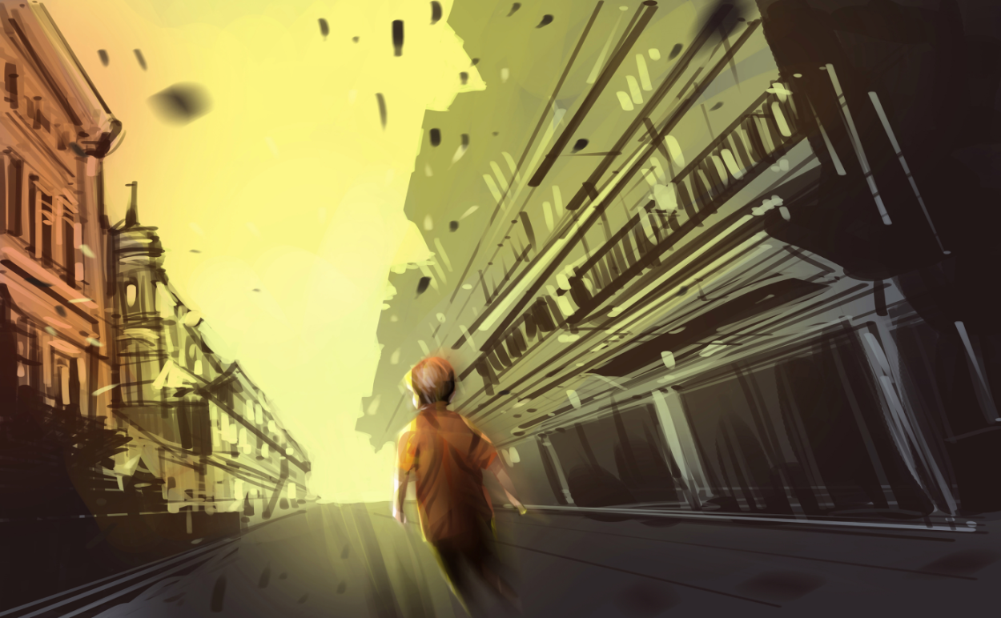

**Part 5**

**WRITING**

*Recommend a book to one of your friends in 160-180 words. Include the following:*

* The title of the book and who wrote it
* What it is about
* Why you think it is worth reading