**[](http://flp.sk/images/stories/friendship/2019-2020/cislo9-10/2020-9-10-Friendship-Methods-of-Transport.mp3)TRANSPORT LESSON – page 13**

**Part 1**

**COMPREHENSION**

*Read and listen. Then answer the questions below.*

**Comprehension check:**

1. Can you name at least 5 means of transport mentioned in the article?
2. Which means of transport is the most eco-friendly: a plane, a car, a bus or a train?
3. Can you name at least 2 futuristic means of transport mentioned in the text?
4. Which means of transport is the author scared of using?
5. What should we do to reduce the amount of international flights?

**Part 2**

**LANGUAGE IN USE**

*Fill in the gaps* ***01-06*** *by choosing the correct expression* ***A, B*** *or* ***C****.*

When you ask people why they  **01** , they usually answer it’s because they want to relax or get  **02**  other places, cultures and people.

**03** , there is a type of travelling that is quite unique and has nothing to do with pleasure or exploring: commuting. Quite the opposite! Commuting  **04** a nightmare especially in big cities. Getting to and from school and work can be tiring, time-consuming and frustrating no matter which means of transport you use. Streets are full of cars and buses stuck in nerve-wrecking traffic jams. Those who decide to ride a bike or walk are in constant danger.

There have been a lot of attempts to cut  **05**  the number of vehicles on city streets by making passengers use public transport but they don’t seem to work. Unless public transport  **06**  faster, cleaner, cheaper and more comfortable, people just won’t give up their cars!

01 A travel B they travel C do they travel

02 A knowing B know C to know

03 A Luckily B But C However

04 A has become B becomes C is becoming

05 A off B down C from

06 A is B isn’t C will be

**Part 3**

***GRAMMAR***

*Use reported speech and questions to complete the sentences below.*

01 “Can I have a return ticket to Bratislava?”

The passenger asked if he ________________________________________.

02 “Is there a bus stop near here?”

The tourist wanted to know if _____________________________________.

03 “How could we get to the railway station?”

The visitors asked how __________________________________.

04 “I’d like to see your passport.”

The lady at the airport told me she ______________________________.

05 “I will have to cancel my flight to Barcelona.”

She said that she ___________________________.

06 “How long did the journey take?”

My host family in London wanted to know _____________________________.

07 “Is the bus leaving in ten minutes?”

The passenger asked the driver if ________________________________.

**Part 4**

**DISCUSSION**

* What is your favourite means of transport? Explain.
* What is the most dangerous means of transport? Why?
* Look at the following list of jobs related to travelling and choose the one that seems the most attractive to you. Can you explain your choice?

Pilot, train driver, ticket inspector, tourist guide, flight attendant, car mechanic

* Look at the following picture and comment on the situation. Do you experience it as well?

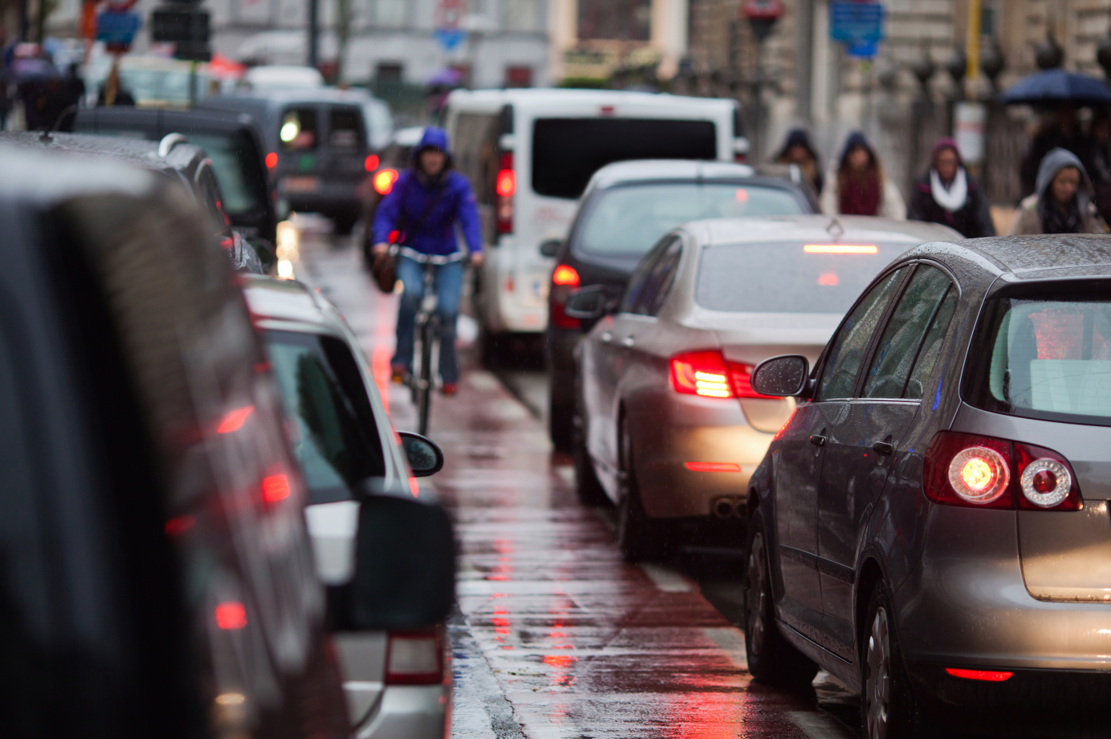

**Part 5**

**WRITING**

Choose two means of transport and compare them (160-180 words). Consider convenience, safety, environmental issues and your own preference.